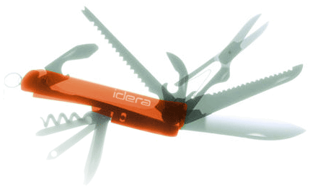

Specification

for

Custom reports

Barry Searle

10/13/2009



Proprietary and Confidential to BBS Technologies, Inc.

© 2009 BBS Technologies, Inc.; all rights reserved.

Revision history:
When? | Who? | What?
08/15/2009 | Barry | Initial Document
8/24/09 | Barry | Revision 1
8/25/2009 | Barry | Rev 2
8/28/2009 | Barry | Incorporated feedback from spec review
10/13/2009 | Barry | Help links

Table of Contents
1. Revision history: ii
2. Table of Contents iii
3. Requirements 1
3.1. Overview/Purpose 1
3.1.1. Related Customer Requests 1
3.2. Target Users 1
3.3. Use Cases 1
3.4. Feature/Function Market Requirements 1
3.4.1. Required Functions 1
3.4.2. Non-Supported Functions 2
3.5. FAQ 2
3.6. Open Issues 2
4. Functional Design 2
4.1. User Interfaces 2
4.1.1. The Navigation Panel 3
4.1.2. Deployment wizard 4
4.1.3. The custom reports View 4
4.1.4. The custom reports wizard 5
4.2. Installation and Upgrade 10
4.3. Permissions and other Required Configuration 10
4.4. Licensing Issues 10
4.5. Dependencies 10
4.5.1. Dependencies on Idera Software 10
4.5.2. Third-Party Software Required on the Customer Machine 10
4.5.3. Third-Party Software Required Internally 10
5. Internal Design 10
5.1. Architecture 10
5.2. Installation Issues 12
5.3. Schedule 12
5.3.1. Work Breakdown and Sizings 12
5.3.2. Areas of Risk 12
6. Quality Assurance Considerations 13
6.1.1. Overview 13
6.1.2. Developer-Created Unit Tests 13
7. Documentation Considerations 13
8. Bibliography 13

Requirements

Overview/Purpose
We would like to create a “catch all” report that can be used by the customer to graph any of our counters or custom counters that they have defined. It should be along the lines of our existing resource reports with graphs of the counters followed by a grid with all of the counters graphed over the selected time frame.

Related Customer Requests

Target Users
This feature targets all alls of SQLdm on SQL Server 2000 and up.

Use Cases
DBA would like to be able to select various counters to be graphed in a report and viewed in the desktop client.
DBA must be able to deploy a custom report.
DBA would like to create a report containing his own custom counters.
DBA deploys a custom report to his reporting services server.
DBA uses the scheduled email feature of our reports view to email himself the custom report
DBA edits an existing custom report.
DBA Saves changes to an existing custom report.
DBA deletes an existing custom report.
The created custom report is immediately available across all consoles.

Feature/Function Market Requirements
We are providing the ability to create a report using any of the SQLdm metrics that we have neglected to include in an existing report, and also for the user to report on their own custom counters.

Required Functions
- DBA must be able to create a report with up to 5 counters that he selects from a list.
- The report must show a graph per counter.
- Report must contain a grid with a column for every selected metric.
- Reports must have the ability to select
- Server
- Period {Today, 7 day,30 day, 365 day}
- Sample {Hours, Day, Week}
- Date Range
- There is no limit to the number of custom reports that can be defined.
- User must be able to deploy the custom reports.
- The custom reports should be viewable from any desktop client connected to the repository.

Non-Supported Functions
- Multi-server graphs.
- Categorization of the counters in the counter selection list.

FAQ
This section should present a high level FAQ that is used to answer common questions from others as they read the spec and also that customers using the feature may ask. This should also provide a start for “He said, She said” documents for sales.

Open Issues

Functional Design

User Interfaces

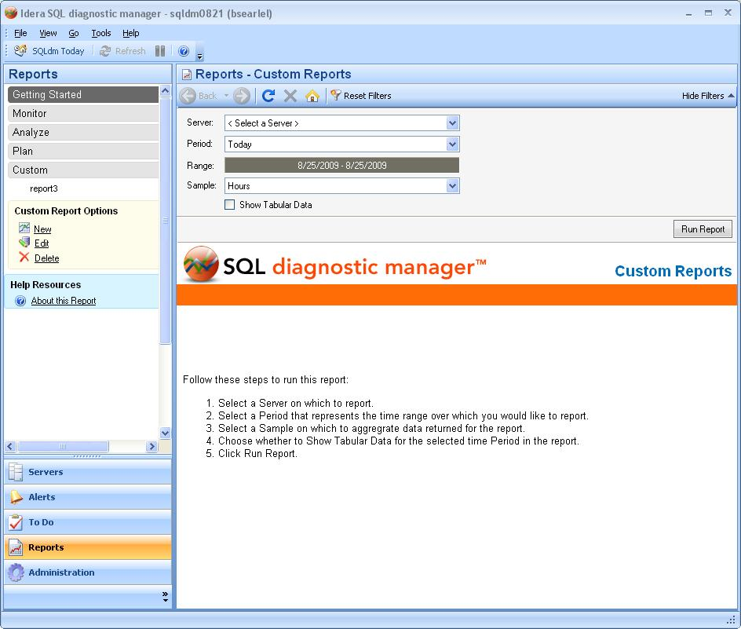

The Navigation Panel
- Custom reports get populated under a new “Custom” node in the navigation tree.
- Clicking on the “Custom” root node or any of the custom report child nodes bring up the “Custom Report Options” option panel if the user has modify rights.
- Always display the New hyperlink
- Display “Edit” when a custom report is selected.
- Display “Delete” when a custom report is selected.
- Clicking on any of the custom reports also brings up the deployment options panel.

Deployment wizard
The deployment wizard will populate with custom reports as well as pre-defined reports.
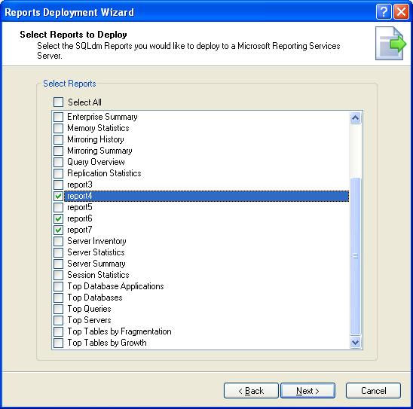

The custom reports View
The view allows the selection of
- the target server,
- period {today, week, month, year},
- range {from - to} and sample {hour, day week, month}
- “show tabular data” checkbox. By default “Show tabular data” is off.

- Show a message “OLE automation is not enabled for this server” if the user tries to view OS metrics on a server which has OLE automation disabled.
- Metrics are displayed with a precision of 2 decimal places.

The report looks the same as our existing resource reports.
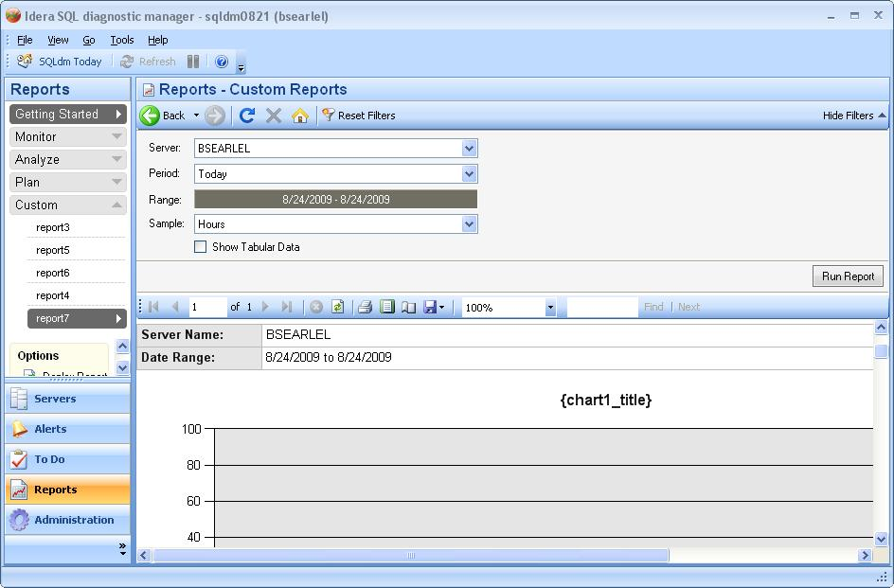

The custom reports wizard
The custom reports wizard is designed to guide a user through the process of creating a custom report or selecting an existing custom report to edit or delete.
- Once a report has been selected the user can choose from a list of available counters to display on the report.
- The next screen enables the user to choose how the counters will be aggregated and give the counters more descriptive names to be used in the series labels of the charts.
- At the end of the custom report is a summary panel giving a brief summary of the options that have been selected in the wizard.

Welcome
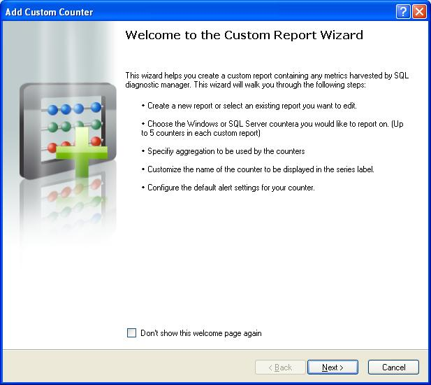

Add or edit a custom report
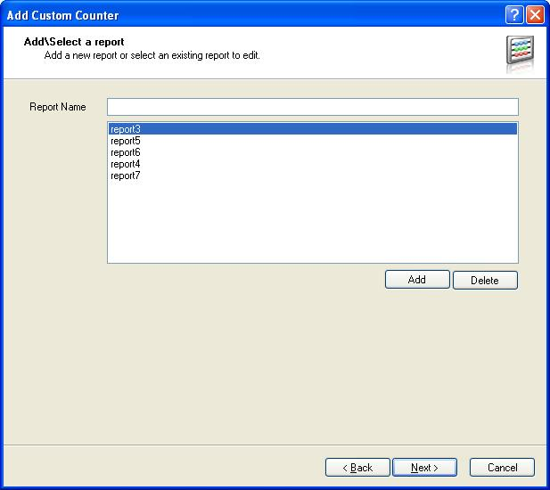
- Deleting will be done directly from the navigation control. No delete button here
- No List here. The user comes here to enter the report name only after clicking New.

Select counters to be displayed in the report
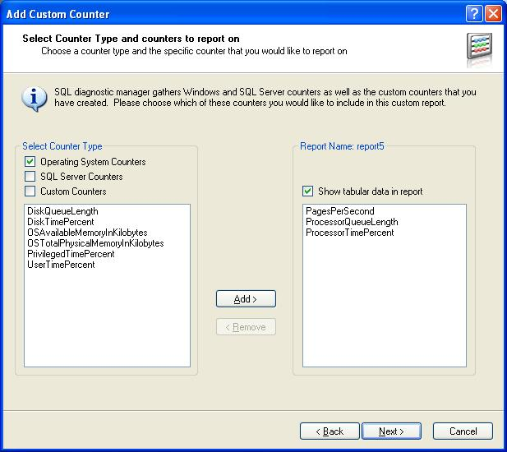
- When a user clicks on edit, this is the screen that they will be brought to.
- It populates with an alphabetically sorted list of counters from our CounterMasterList table.
- Typing part of a counter name must highlight a match in the grid.
- Have a NOTE: Only 5 counters can be displayed in a report.
- User is programmatically limited to 5 selections.

Select aggregation and series name
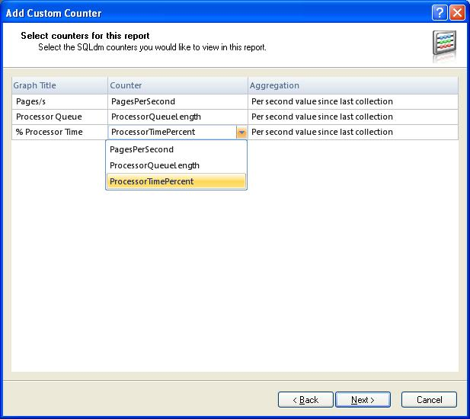
Columns:
- Graph Title
- Counter
- Aggregation {Average since last collection, maximum since last collection, average per second since last collection, use the raw counter}
Rather than having the chart number in the grid, I will put buttons in the grid to move the row up or down. The chart number can therefore be derived by the position.

Summary and finish
After selecting the counters that will go in the report we have a summary of what counters and aggregation have been selected for this report.
When the finish button is clicked the setting are written to the repository and if the report the settings pertain to is open in the custom report control, a refresh will automatically take place.

Help Links
@"Adding a Custom Report.htm" when in the wizard in add mode.
@"Editing a Custom Report.htm" when in the wizard in edit mode.
@"Selecting Counters in a Custom Report.htm" when on the select counters page.
@"Aggregating counters in a Custom Report.htm" when on the counter aggregation page.

Installation and Upgrade

Permissions and other Required Configuration
User needs modify rights to create, edit or delete a report. The custom reports panel will not be show to view only users. Anyone can see a report. Server\tag rights are enforced in the server dropdown as they are in every other report.

Licensing Issues

Dependencies

Dependencies on Idera Software

Third-Party Software Required on the Customer Machine

Third-Party Software Required Internally

Internal Design

Architecture
There is a custom reports table in the repository that stores the name of the report and the rdl of the report. When loading the report navigation pane we query the repository to get the list of custom reports that have been defined in the repository. When the user selects a report, we pass the selection to the custom report control which then queries the repository for the rdl of the report. The report is rendered in exactly the same way as if the rdl came from an embedded report.

Tables
The details of the report are stored in the CustomReports table.
- Custom Report ID
- Report Name
- Report short description (friendly name)
- ReportText (RDL) – nText field

The details of the selected counters are stored in the CustomReportsCounters table.
- Custom Report ID
- Graph number
- Counter short description (friendly name)
- Counter Name
- Aggregation {0 sum, average, raw value}

CounterMasterList table should be created to keep track of all counters which we monitor in SQLdm. This list needs to contain the type of the counter as well as the column name within ServerStatsitics and OSStatistics. Custom Counters already have a descriptive name
- Column Name
- Friendly name
- Counter type {0 = Server, OS}

Creating the rdl
The rdl code is created using the header and footer of our existing resource reports with charts and the grid added using the .Net XMLWriter. The report xml is written to the repository using WriteText and UpdateText for modifying ntext fields.

Listing the counters
Counters are currently stored in ServerStatistics and OSStatistics table. I am selecting the column names from sysobects to get the names of the counters. The custom counters are stored in a less normalized table with a counter id as the key.
We need a CounterMasterList table containing a friendly name for each of the OS, Server counters as well as the column name and table name so we can display more user friendly counter names. All custom counters are displayed regardless of whether or not they are enabled

Installation Issues
Insert changes for installation – new files to be dropped, new configuration screens etc. Think about the initial install and upgrade cases.

CustomReportWizard
CustomReport view.
CustomReport Table
CustomReportCounters table
p_UpdateCustomReport stored procedure in the management service.
P_GetCustomReport on the desktop client.

Schedule

Work Breakdown and Sizings
Insert areas that put the implementation or schedule at risk – Assumptions made in design, new areas that have a learning curve etc. Break the project into logical components and add time for design, coding, integration, unit testing. These estimates should not take into account outside forces like maintenance work. These will be applied in building the overall project schedule. A general rule of thumb is to break any unit of work greater then 1 week into smaller pieces to ensure accuracy and to allow measurement of progress during the project.
Component | Who | Sizing
R&D | Barry | 0 days
Report parsing and XML. Dynamic creation of report | Barry | 3 days
Custom Report wizard | Barry | 2 days
Custom Report View | Barry | 2 days
Unit and Integration Testing | Barry | 1 days
Total |  | 8 days

Areas of Risk
There are many types of risks. For example, a section might describe
- Areas with big learning curve
- Design assumptions that still need to be proven
- a technical hurdle that needs to be overcome.
- An area which has many unknowns
- Outcomes of other plans/implementations which could affect the deliverability of this feature.
Where possible, each section should explain the risk, quantify the risk, enumerate possible actions to address the risk, and recommend the action that is appropriate.

Quality Assurance Considerations

Overview
Pay particular attention to very large values, very small values, and null values in the data sets that are being used to generate the reports.

We need to give a useful error when no OS metrics exist because OS collection is not enabled for the server being reported on.

Developer-Created Unit Tests
Automated, Developer-Created Unit Tests which will be Created (and Passed to QA)
Developer Tests which will be Manually Performed

Documentation Considerations

Bibliography

